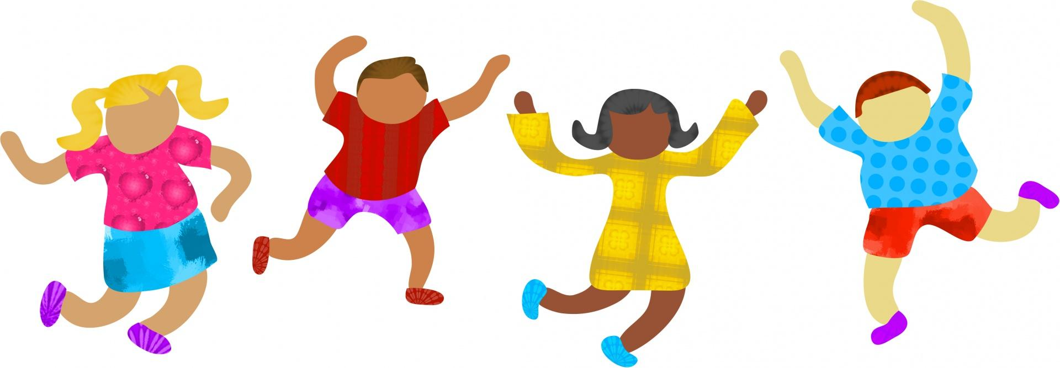
FABIUS-POMPEY ELEMENTARY SCHOOL

2024-2025 Kindergarten Supply List

Crayons – No more than 24- I will give them a small container.
- Scissors (Fiskars)- labeled
- Pencils (3-4)- not labeled
- Glue Sticks – no liquid glue
- Old Adult pullover T-Shirt for Art Smock- labeled
- Large Backpack that can fit winter clothes- labeled
- Sneakers with velcro- labeled- They need sneakers every day.
- 2 boxes of tissues- not labeled
- 1 Box Ziploc Storage Bags gallon size- not labeled
- 4 pack of playdough- not labeled
- Personal coloring book (choose one your child likes)- labeled
- 1 container of Clorox (or other brand) wipes to clean tables- not labeled
- Package of Low Odor Expo Markers- not labeled
- Package of flushable wipes- not labeled
- Set of pants, underwear, socks, and shirt for emergencies- label the bag.

Please label all clothes that come into school- all coats and sweatshirts. It is AMAZING how no one can tell if it is theirs when it is laying in the hallway.

Please do NOT send individual workboxes- Thanks!

